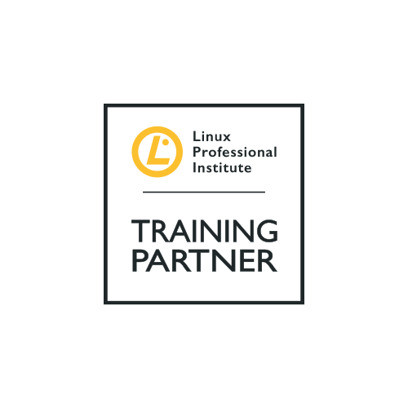

COURSE OUTLINE

Course Name: LPI Linux Essentials

|  |  |  |  |  |
| --- | --- | --- | --- | --- |
| **DURATION** | **SKILL LEVEL** | **DELIVERY**  **METHOD** | **TRAINING**  **CREDITS** | **TECHNOLOGY** |
| 5 days | Introduction | Instructed-Led/ VILT | N/A | Linux Operating System |

**Course Description:**

The Linux Professional Institute Linux Essentials course provide delegates with the skills and knowledge to use a basic

command-line editor and demonstrate an understanding of processes, programs and components of the Linux operating

system.

Whether you are starting your career in Open Source or looking for advancement, independently verifying your skills set can help you stand out to hiring managers or your management team. The entry-Level Linux Essentials course is a great way to show that you have the foundational skills required for your next job or promotion. It also serves as an ideal stepping-stone to the more advanced LPIC professional courses such as LPIC-1, LPIC-2 and LPIC-3.

**Prerequisites:**

There are no prerequisites for this certification.

**Target Audience:**

The Linux Essentials course is designed for students that are

new to Linux technologies.

**Learning Objectives:**

The Linux Essentials certificate validates a demonstrated

understanding of the following:

* FOSS, the various communities, and licenses.
* Knowledge of open source applications in the workplace

as they relate to closed equivalents

* Basic concepts of hardware, processes, programs and

the components of the Linux Operating System.

* How to work on the command line and with files
* How to create and restore compressed backups and

Archives

* System security, users/groups and file permissions for

public and private directories.

* How to create and run simple scripts

**Course Outline:**

**Lesson 1: The Linux Community and a Career in**

**Open Source**

* Linux Evolution and Popular Operating Systems
* Major Open Source Applications
* Open Source Software and Licensing
* ICT Skills and Working in Linux

**Lesson 2: Finding Your Way on a Linux System**

* Command Line Basics
* Using the Command line to Get Help
* Using Directories and Listing Files
* Creating, Moving and Deleting Files

**Lesson 3: The Power of the Command Line**

* Archiving Files on the Command Line
* Searching and Extracting Data from files
* Turning Commands into Script

**Lesson 4: The Linux Operating System**

* Choosing an Operating System
* Understanding Computer Hardware
* Where Data is Stored
* Your Computer on the Network

**Lesson 5: Security and File Permissions**

* Basic Security and Identifying User Types
* Creating Users and Groups
* Managing File Permissions and Ownership
* Special Directories and Files

**Associated Exam and Certification:**

This course will prepare students to take the **LPI Linux Essentials Exam 010-160**

Successfully passing this exam will result in the attainment of the **Linux Professional Institute Linux Essentials Certification.**

After completing this course, students will receive a Netcampus course attendance certification.

**Exams and Certifications**

**Follow on Course:**

Link to the next recommended course -link to course on website